Unity Physics

Creating a simple chain in the Editor

- Create a Sphere above a Plane at (0,7,0) called Anchor. Give it scale (0.5f, 0.5f, 0.5f).
- Add a RigidBody. Make this Kinematic
- Create a second sphere at (0,6,0) called Link1, with Is Kinematic set to false, and give it a Spring Joint. Set the Spring to 500 and the other RigidBody to Anchor
- Copy and Paste Link1 to create Link2 – Link 5, each 1 unit below the previous one. Link each one's spring to the previous sphere.
- Run it. Grab the anchor and move it around. See how it behaves like an elastic rope.
- Place the Anchor and Links into a empty object called Spring Chain
- Copy and paste this empty object, renaming it Fixed Chain.
- Go through the five links of Fixed Chain and remove each Spring Joint and replace with a Fixed Joint, and link up the links in order.
- Place this Fixed Chain object 3 units to the left. See how it behaves when you grab its anchor and shake it. (Not well)
- Make a Hinge Chain object copy of Fixed Chain, and replace the Fixed Joints with Hing Joints, and link up the objects. See how this behaves. (This one makes the best rope, with or without “Use Springs” ticked.)

Let's Code
It's going to be easiest for us to experiment if we can programatically create chains and other joints.

Create an empty object called CodeObject1 at position (6,7,0) – right of the editor created chains. Add a custom script to it called SoftBody, and we'll use this to set up a chain in code.
We'll need to set up a basic physics sphere to work with, so lets make a prefab.
- Assets > Create > Prefab in the main menu.
- Rename the Prefab to PhysicsSphere
- Drag the Anchor object from one of the chains into the prefab
- Set the RigidBody “is Kinematic” to false
- Set scale to 0.5f in all directions.
- Go to your Assets folder in Explorer, and put the prefab file into a subfolder called “Resources”

We'll start by setting the SoftBody script to create a string of HingeJoint-connected balls.
In the Start function we'll do the following
- Spawn an anchor, based on our PhysicsSphere prefab.
- Spawn a number of links below it
- Connect each link to the ball above it using a HingeJoint.

Here's how to get a reference to a prefab. You have to reference the prefab relative to the Resources folder for this to work.
GameObject ball = Resources.Load<GameObject>("PhysicsSphere");

Here's how to neatly spawn a new GameObject so that it's a named child of the empty object to which the script is attached. We also talk to the Rigidbody component on the new object here.

Vector3 pos = transform.position;

//instantiate an anchor and make it our child
GameObject anchor = Instantiate(ball, pos, transform.rotation) as GameObject;
anchor.transform.parent = gameObject.transform;
anchor.name = "Anchor";
anchor.GetComponent<Rigidbody>().isKinematic = true;

The prefab is set up to have a Rigidbody, a Mesh and a Mesh Renderer. It has no joints, but we want all the links to have a joint connecting them to the previous one. Here's some sample code for programatically adding a new Component and setting some properties on it.

GameObject[] links = new GameObject[numLinks];
for (int i=0;i< numLinks; i++)
{
// TODO spawn a link similar to how we spawned the anchor, and make it not Kinematic

// add a hinge to the anchor (for the first link) or the previous link
HingeJoint joint = links[i].AddComponent<HingeJoint>();
joint.connectedBody = (i == 0 ? anchor : links[i - 1]).GetComponent<Rigidbody>();

// set up the anchors manually from centre to centre
joint.anchor = new Vector3(0, 0, 0);
joint.connectedAnchor = new Vector3(0, -1.0f, 0);
}

Use these code snippets to recreate the HingeJoint rope purely from code.

This is my project before running. There are three different editor setup chains, and the empty object with just a SoftBody script in it.

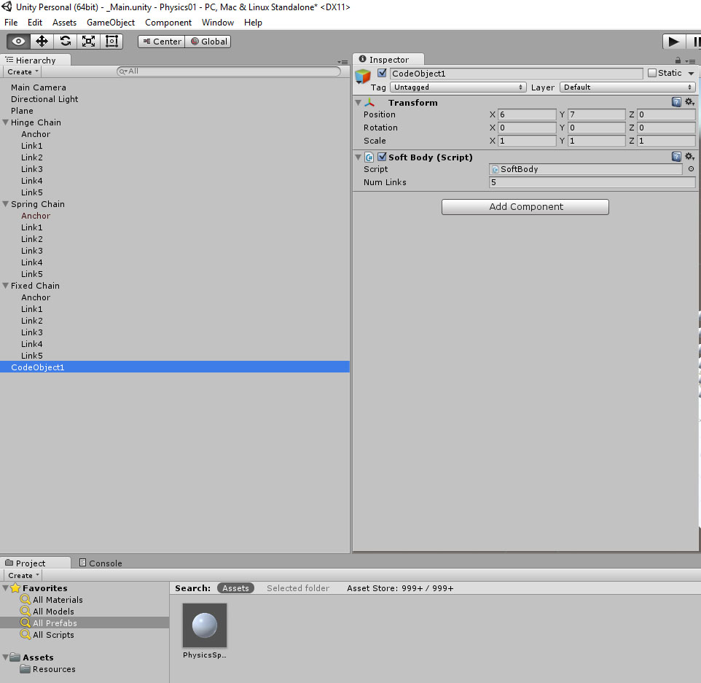

And this is it after. The Softbody now has some neatly named and organised children with programatically created properties.
(The screen is pink via Edit > Preferences > Colours > Playmode Tint. This is a helpful visual cue to stop you from adding objects (and then losing them) in Play mode.)

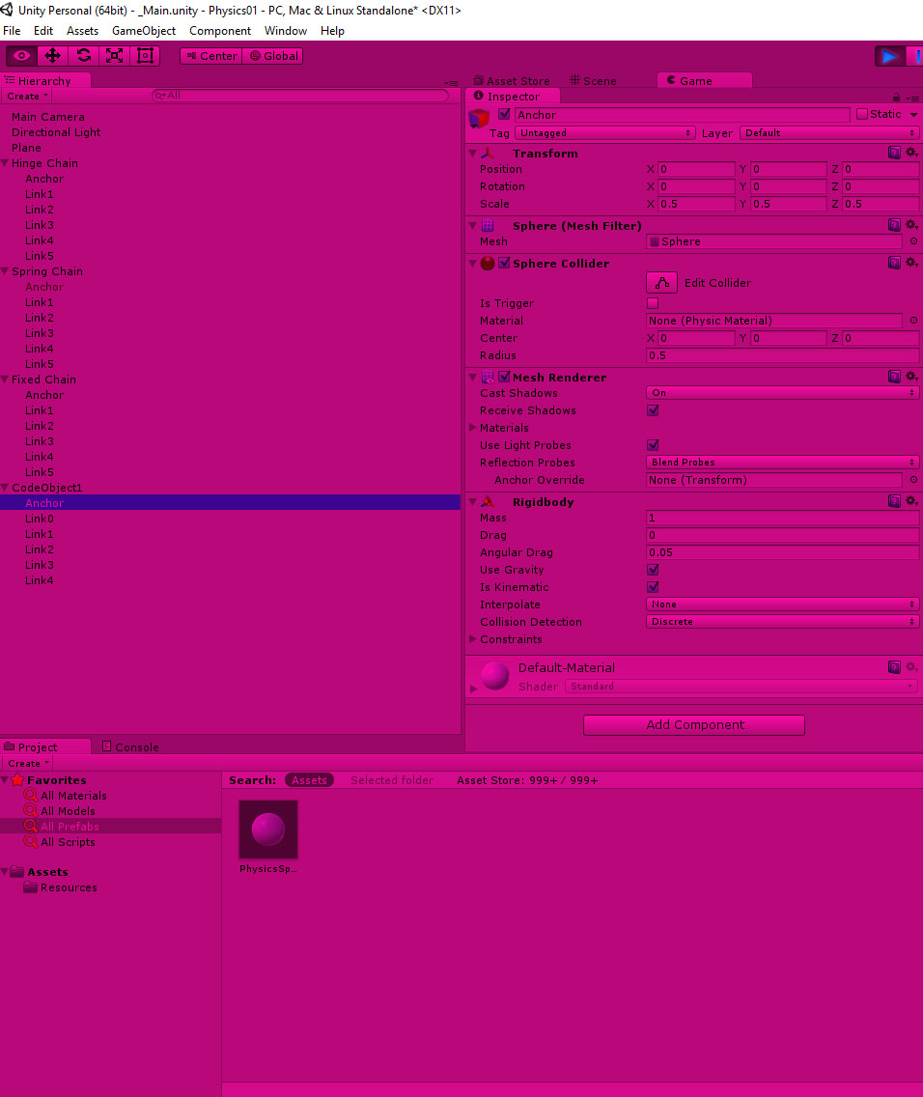
Tutorial Exercise.
Parametrise the SoftBody script. Give it a public members for number of elements, the scale of the balls (defaults to 0.5f) and the spacing between them.
Try setting up different kinds of joints, and parametrising the script to do this too via an enum for the type of joints it uses.

